Microscopic Urinalysis
Microscopic examination is an indispensable part of urinalysis; the identification of casts, cells, crystals, and bacteria aids in the diagnosis of a variety of conditions. To prepare a urine specimen for microscopic analysis, a fresh sample of 10 to 15 mL of urine should be centrifuged at 1,500 to 3,000 rpm for five minutes. The supernatant then is decanted and the sediment resuspended in the remaining liquid.37 A single drop is transferred to a clean glass slide, and a cover slip is applied.
CELLS
1) Squamous epithelial cells and leukocytes:
Epithelial cells often are present in the urinary sediment. Squamous epithelial cells are large and irregularly shaped, with a small nucleus and fine granular cytoplasm; their presence suggests contamination. The presence of transitional epithelial cells is normal. These cells are smaller and rounder than squamous cells, and they have larger nuclei. The presence of renal tubule cells indicates significant renal pathology
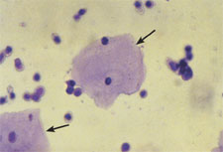

2) Erythrocytes: are best visualized under high-power magnification. Dysmorphic erythrocytes, which have odd shapes because of their passage through an abnormal glomerulus, suggest glomerular disease.
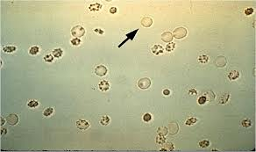
CASTS
Casts in the urinary sediment may be used to localize disease to a specific location in the genitourinary tract. Casts, which are a coagulum of Tamm-Horsfall mucoprotein and the trapped contents of tubule lumen, originate from the distal convoluted tubule or collecting duct during periods of urinary concentration or stasis, or when urinary pH is very low. Their cylindrical shape reflects the tubule in which they were formed and is retained when the casts are washed away. The predominant cellular elements determine the type of cast: hyaline, erythrocyte, leukocyte, epithelial, granular, waxy, fatty, or broad.
Urinary Casts and Associated Pathologic Conditions

Type of cast | Composition | Associated conditions
Hyaline | Mucoproteins | Pyelonephritis, chronic renal disease
Erythrocyte | Red blood cells | Glomerulonephritis
Leukocyte | White blood cells | Pyelonephritis, glomerulonephritis, interstitial nephritis, renal inflammatory processes
Epithelial | Renal tubule cells | Acute tubular necrosis, interstitial nephritis, eclampsia, nephritic syndrome, allograft rejection, heavy metal ingestion, renal disease
Granular | Various cell types | Advanced renal disease
Waxy | Various cell types | Advanced renal disease
Fatty | Lipid-laden renal tubule cells | Nephrotic syndrome, renal disease, hypothyroidism

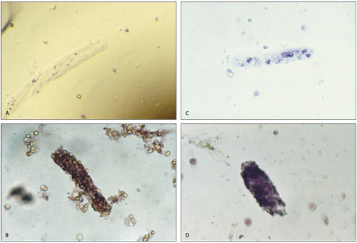

Urinary casts. (A) Hyaline cast (200 X); (B) erythrocyte cast (100 X); (C) leukocyte cast (100 X); (D) granular cast (100 X)

CRYSTALS
Crystals may be seen in the urinary sediment of healthy patients. Calcium oxalate crystals have a refractile square “envelope” shape that can vary in size. Uric acid crystals are yellow to orange-brown and may be diamond- or barrel-shaped. Triple phosphate crystals may be normal but often are associated with alkaline urine and UTI (typically associated with Proteus species). These crystals are colorless and have a characteristic “coffin lid” appearance. Cystine crystals are colorless, have a hexagonal shape, and are present in acidic urine, which is diagnostic of cystinuria.
